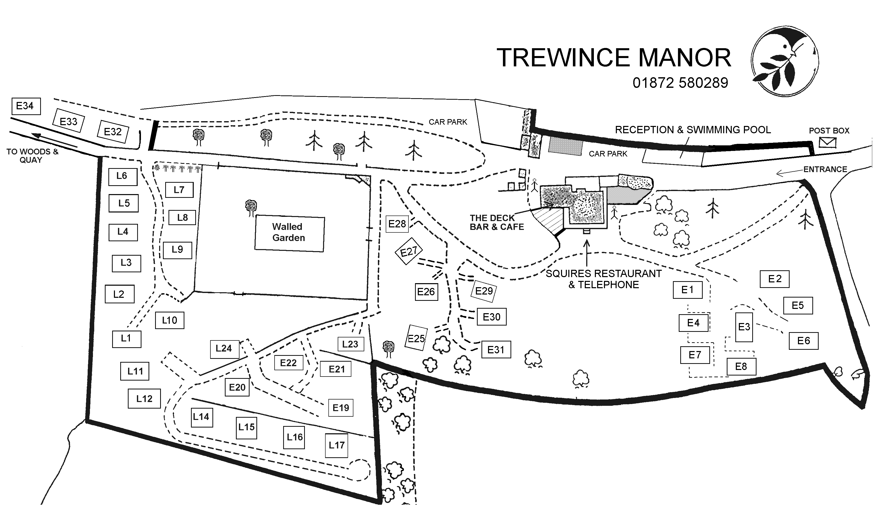
Parking for E22
Parking for E22
-
Parking for E22
-
Parking for E22

